Contenido

Capitulo 2 2

**Chapter 3.** 15

**Character, Number and Miscellaneous Functions** 15

**3.1.2. Concatenate Strings** 19

**Lab 3.2 3.2.1. Use Number Functions and Perform Mathematical** 20

**Computations**. 20

**3.3.1. Apply Substitution Functions and Other Miscellaneous Functions** 21

3.3.2. Utilize the Power of the DECODE Function and the CASE Expression 22

**Chapter 4. Date and Conversion Functions** 24

Chapter 5 Equijoins 27

Lab 6.1 The Two-Table Join 27

Lab 6.1 Exercises 29

Lab 6.2 Exercises 32

6.2.1. Join Three or More Tables 32

Chapter 7. Subqueries 34

Lab 7.1 Exercises 34

7.2 exercises 43

Lab 7.4 Exercise 45

Chapter 8. Set Operators 48

Lab 8.1 Exercises 49

Lab 8.2 Exercises 52

Chapter 9. Complex Joins 54

Lab 9.1 Exercises 56

# Capitulo 2

rem [Rischert, 2004,148]

SELECT description

FROM grade_type

WHERE description >= 'Midterm'

AND description <= 'Project';

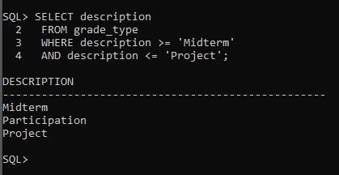

e) Execute the following query and determine how many rows the query returns. SELECT last_name, student_id FROM student WHERE ROWNUM <= 10

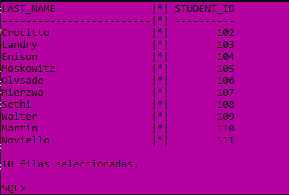

SELECT ROWNUM, last_name, student_id FROM student WHERE ROWNUM <= 10

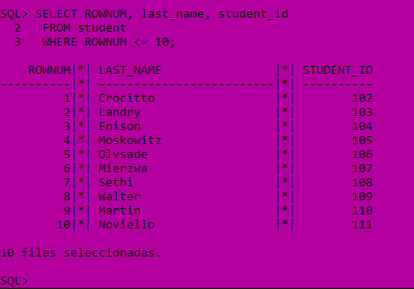

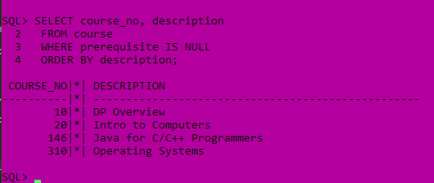

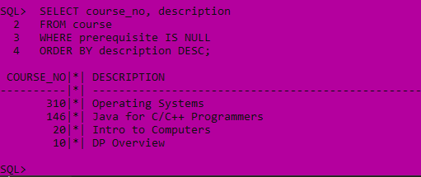

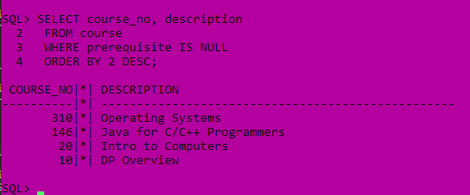

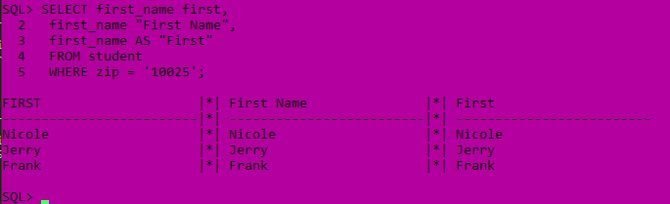

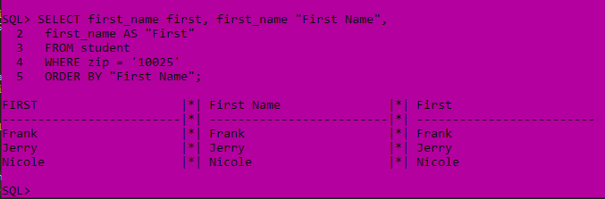

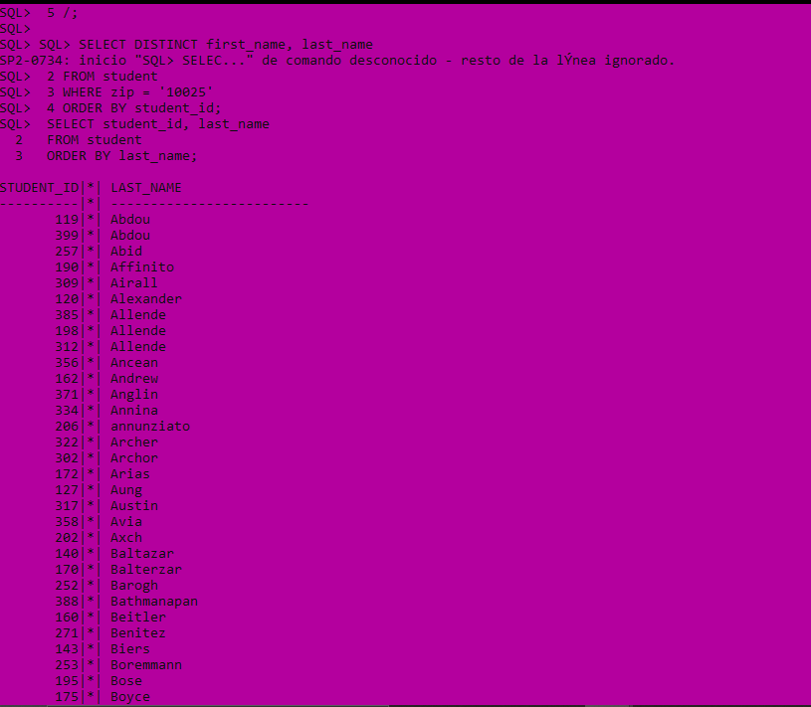





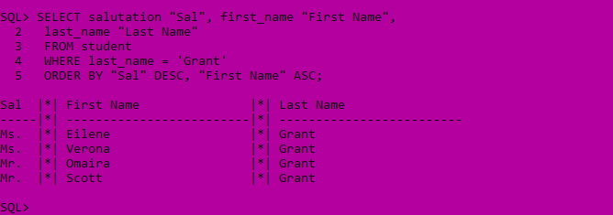

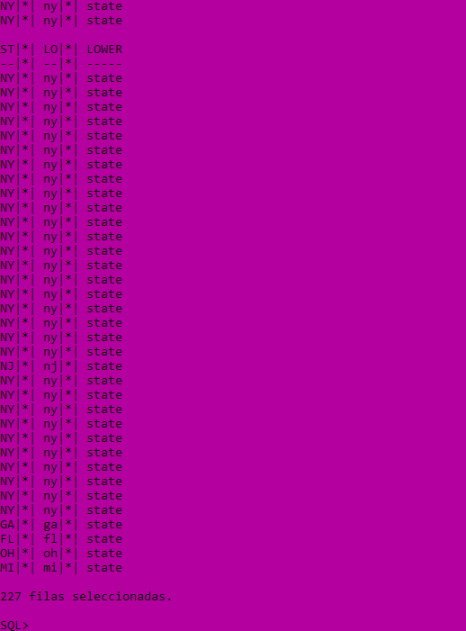

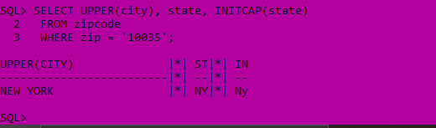

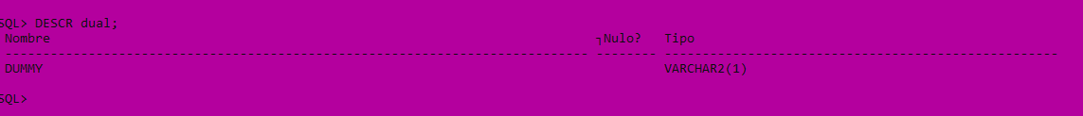



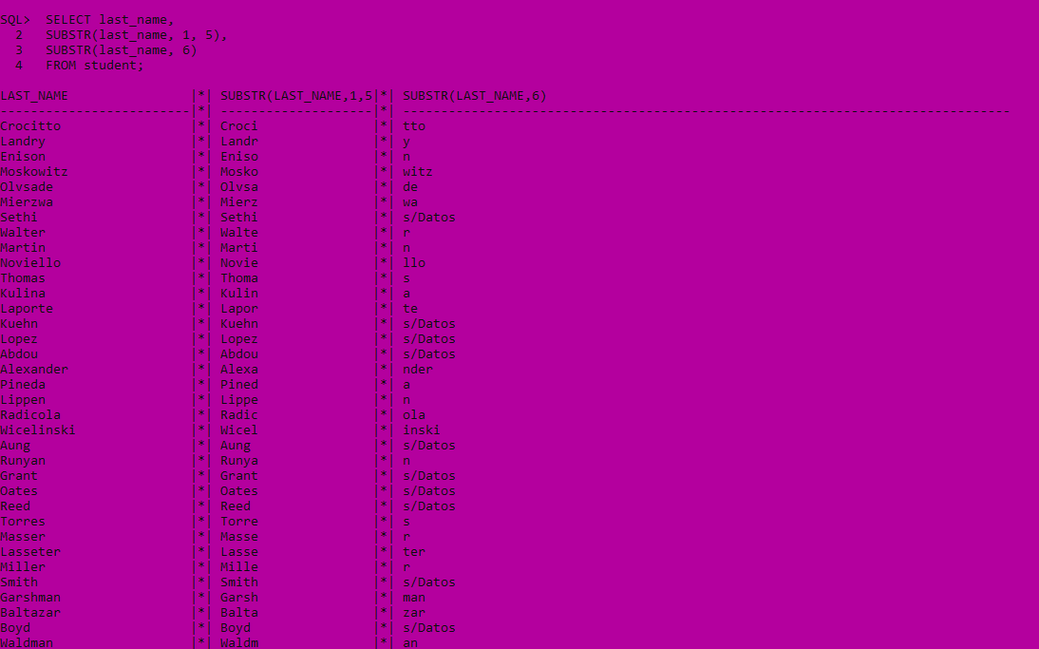









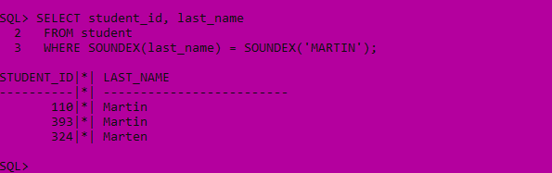

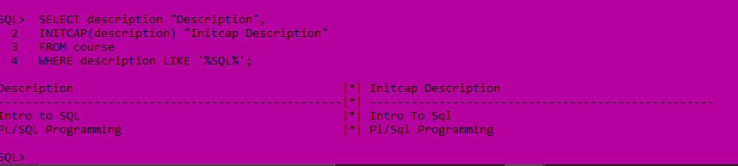







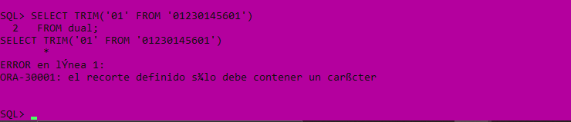











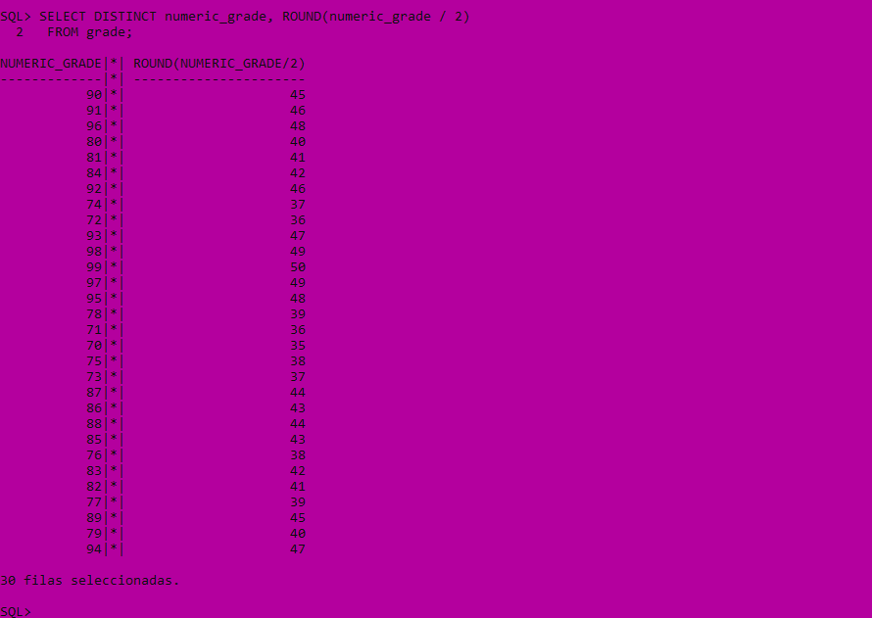

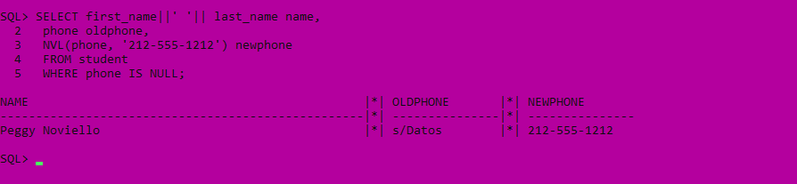

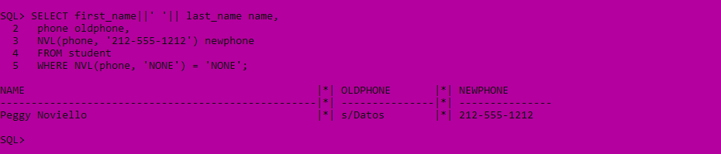



# **Chapter 3.**

## **Character, Number and Miscellaneous Functions**

Lab 3.1 Exercises

3.1.1. Use a Character Function in a SQL Statement

a) Execute the following SQL statement. Based on the result, what is the purpose of the INITCAP function?

SELECT description "Description",

INITCAP(description) "Initcap Description"

FROM course

WHERE description LIKE '%SQL%'

Con la primer sentencia podemos observar que al momento de ingresarla no funciona.

b) Write the question answered by the following SQL statement.

SELECT last_name

FROM instructor

WHERE LENGTH(last_name) >= 6

La sentencia nos devuelve los apellidos que tengan seis o mas letras.

c) Describe the result of the following SQL statement. Pay particular attention to the egative number parameter.

SELECT SUBSTR('12345', 3),

SUBSTR('12345', 3, 2),

SUBSTR('12345', -4, 3)

FROM dual

En la Columba SUBSTR toma los números a partir de la tercera posición, en la segunda Columba, toma los primeros dos valores a partir del tercero y en la tercer columna como es un número negativo empieza desde el final de la cadena, por lo tanto comienza a contar a partir del dos, tomando solamente tres caracteres.

d) Based on the result of the following SQL statement, describe the purpose of the LTRIM and RTRIM functions.

SELECT zip, LTRIM(zip, '0'), RTRIM(ZIP, '4')

FROM zipcode

ORDER BY zip

e) What do you observe when you execute the next statement? How would you change the statement to achieve the desired result?

SELECT TRIM('01' FROM '01230145601')

FROM dual

f) What is the result of the following statement?

SELECT TRANSLATE('555-1212', '0123456789',

'##########')

FROM dual

g) Write the SQL statement to retrieve those students that have a last name with the lowercase letter 'o' occurring three or more times.

h) The following statement determines how many times the string 'ed' occurs in the phrase 'Fred fed Ted bread, and Ted fed Fred bread.' Explain how this is accomplished.

SELECT (

LENGTH('Fred fed Ted bread, and Ted fed Fred bread.') -

LENGTH(REPLACE('Fred fed Ted bread, and Ted fed Fred bread.',

'ed', NULL))

) /2 AS occurr

FROM dual

OCCURR

----------

6

1 row selected.

## **3.1.2. Concatenate Strings**

1. Write a SELECT statement that returns each instructor's last name, followed by a comma and a space, followed by the instructor's first name, all in a single column in the result set.

b) Using functions in the SELECT list, WHERE, and ORDER BY clauses, write the SELECT statement that returns course numbers and course descriptions from the COURSE table and looks like the following result set:

Description

-------------------------------------

204.......Intro to SQL

130.......Intro to Unix

230.......Intro to Internet

20........Intro to Computers

25........Intro to Programming

120.......Intro to Java Programming

240.......Intro to the Basic Language

7 rows selected.

## **Lab 3.2 3.2.1. Use Number Functions and Perform Mathematical**

## **Computations**.

a) Describe the effect of the negative precision as a parameter of the ROUND function in

the following SQL statement.

SELECT 10.245, ROUND(10.245, 1), ROUND(10.245, -1)

FROM dual

b) Write a SELECT statement that displays distinct course costs. In a separate column, show the COST increased by 75% and round the decimals to the nearest dollar.

c) Write a SELECT statement that displays distinct numeric grades from the GRADE table and half those values expressed as a whole number in a separate column.

## **3.3.1. Apply Substitution Functions and Other Miscellaneous Functions**

a) List the last name, first name, and phone number of students who do not have a phone

number. Display '212-555-1212' for the phone number.

b) For course numbers 430 and greater, show the course cost. Add another columna reflecting a discount of 10% off the cost and substitute any NULL values in the COST column with the number 1000. The result should look similar to the following output.

COURSE_NO COST NEW

-------------- ------- ------

430 1195 1075.5

450 900

2 rows selected.

c) Write the query to accomplish the following output using the NVL2 function in the column 'Get this result'.

ID NAME PHONE Get this result

------------------ ------------ -----------------

112 Thomas Thomas 201-555-5555 Phone# exists.

111 Peggy Noviello No phone# exists.

2 rows selected.

## 3.3.2. Utilize the Power of the DECODE Function and the CASE Expression

a) Rewrite the query from Exercise 3.3.1 c) using the DECODE function instead.

b) For course numbers 20, 120, 122, and 132, display the description, course number, and

prerequisite course number. If the prerequisite is course number 120, display 200; if the

prerequisite is 130, display 'N/A'. For courses with no prerequisites, display 'None'.

Otherwise, list the current prerequisite. The result should look like the one listed below.

COURSE_NO DESCRIPTION ORIGINAL NEW

--------- ------------------------------ -------- ----

132 Basics of Unix Admin 130 N/A

122 Intermediate Java Programming 120 200

120 Intro to Java Programming 80 80

20 Intro to Computers None

4 rows selected.

c) Display the student ID, zip code, and phone number for students with student IDs 145, 150, or 325. For those students living in the 212 area code and in zip code 10048, display 'North Campus'. List students living in the 212 area code but in a different zip code as 'West Campus'. Display students outside the 212 area code as 'Off Campus'. The result should look like the following output. Hint: The solution to this query requires nested DECODE functions or nested CASE expressions.

STUDENT_ID ZIP PHONE LOC

---------- ----- --------------- ------------

145 10048 212-555-5555 North Campus

150 11787 718-555-5555 Off Campus

325 10954 212-555-5555 West Campus

3 rows selected

d) Display all the distinct salutations used in the INSTRUCTOR table. Order them alphabetically except for female salutations, which should be listed first. Hint: Use the DECODE function or CASE expression in the ORDER BY clause.

# **Chapter 4. Date and Conversion Functions**







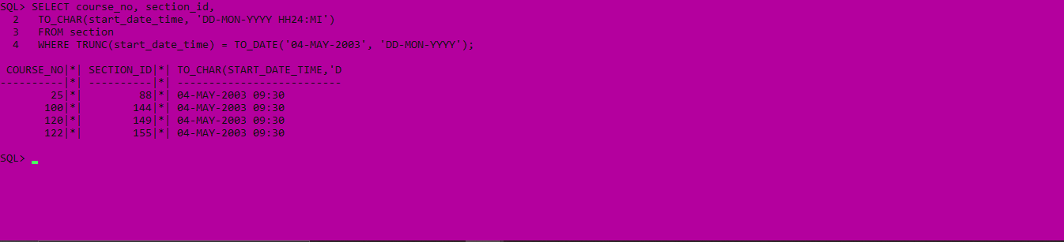







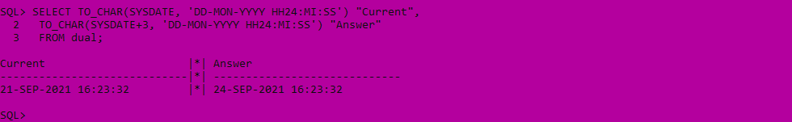

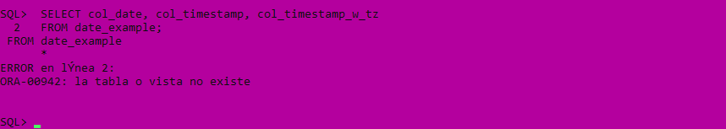

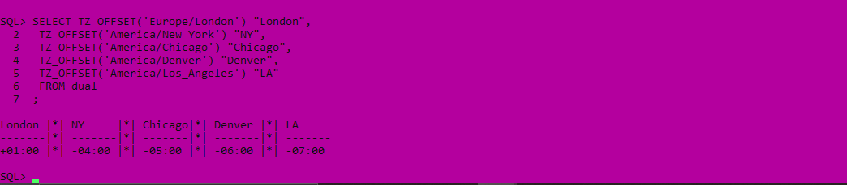

# Chapter 5 Equijoins

## Lab 6.1 The Two-Table Join

rem [Rischert, 2004,330]

SELECT c.course_no, s.section_no, c.description,

s.location, s.instructor_id

FROM course c, section s

rem [Rischert, 2004,331]

SELECT course_no, s.section_no, c.description,

s.location, s.instructor_id

FROM course c JOIN section s

USING (course_no);

rem [Rischert, 2004,334]

SELECT COUNT(*)

FROM section, instructor;

rem [Rischert, 2004,334]

SELECT s.instructor_id s_instructor_id,

i.instructor_id i_instructor_id

FROM section s, instructor i;

## Lab 6.1 Exercises

6.1.1. Write Simple Join Constructs

a) For all students, display last name, city, state, and zip code. Show the result ordered by zip code.

SELECT s.last_name, s.zip, z.state, z.city

FROM student s, zipcode z

WHERE s.zip = z.zip ORDER BY s.zip

6.1.2. Narrow Down Your Result Set

a) Execute the following SQL statement. Explain your observations about the WHERE clause and the resulting output.

SELECT c.course_no, c.description, s.section_no

FROM course c, section s

WHERE c.course_no = s.course_no AND c.prerequisite

IS NULL ORDER BY c.course_no, s.section_no

rem [Rischert, 2004,339]

SELECT c.course_no, c.description, s.section_no

FROM course c, section s

WHERE c.course_no = s.course_no

AND c.prerequisite IS NULL

ORDER BY c.course_no, s.section_no;

rem [Rischert, 2004,340]

SELECT e.student_id, s.course_no,

TO_CHAR(e.enroll_date,'MM/DD/YYYY HH:MI PM'),

e.section_id

FROM enrollment e JOIN section s

ON (e.section_id = s.section_id)

WHERE s.course_no = 20

AND e.enroll_date >= TO_DATE('01/30/2003','MM/DD/YYYY')

AND e.enroll_date < TO_DATE('01/31/2003','MM/DD/YYYY');

rem [Rischert, 2004,341]

SELECT s.student_id, i.instructor_id,

s.zip, i.zip

FROM student s, instructor i

WHERE s.zip = i.zip

ORDER BY s.student_id, i.instructor_id;

# Lab 6.2 Exercises

## 6.2.1. Join Three or More Tables

Display the student ID, course number, and section number of enrolled students where the instructor of the section lives in zip code 10025. Additionally, the course should not have any prerequisites.

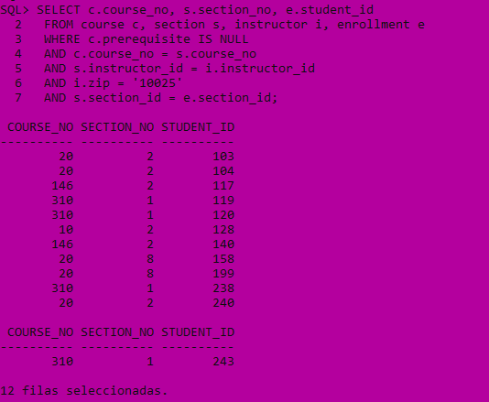

rem [Rischert, 2004,358]

SELECT last_name, first_name

FROM student

WHERE last_name = 'Crocitto'

AND first_name = 'Fred';

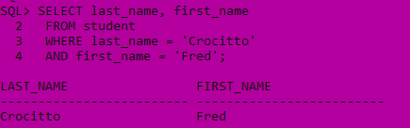

# Chapter 7. Subqueries

## Lab 7.1 Exercises

rem [Rischert, 2004,376]

SELECT first_name, last_name

FROM student

WHERE registration_date =

(SELECT MIN(registration_date)

FROM student);

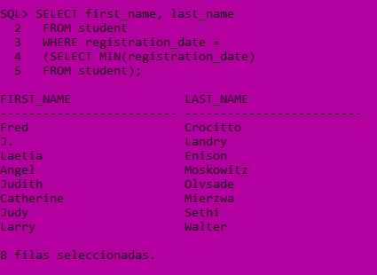

rem [Rischert, 2004,376]

SELECT c.description, s.section_no, c.cost, s.capacity

FROM course c, section s

WHERE c.course_no = s.course_no

AND s.capacity <=

(SELECT AVG(capacity)

FROM section)

AND c.cost =

(SELECT MIN(cost)

FROM course);

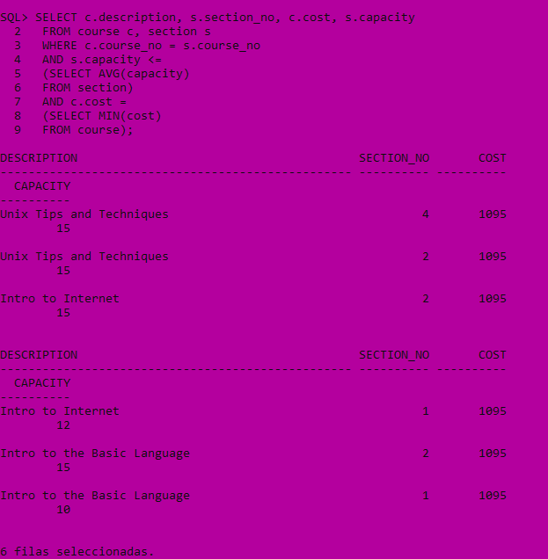

rem [Rischert, 2004,376]

SELECT c.description, s.section_no, c.cost, s.capacity

FROM course c, section s

WHERE c.course_no = s.course_no

AND s.capacity <=

(SELECT AVG(capacity)

FROM section)

AND c.cost =

(SELECT MIN(cost)

FROM course);

rem [Rischert, 2004,381]

SELECT instructor_id, last_name, first_name, zip

FROM instructor i

WHERE EXISTS

(SELECT 'X'

FROM section

WHERE i.instructor_id = instructor_id);

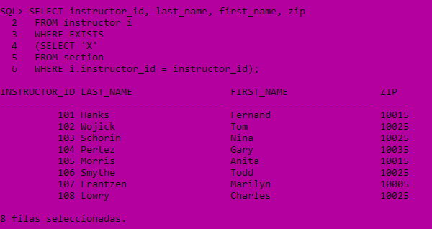

rem [Rischert, 2004,388]

SELECT section_id, capacity

FROM section

WHERE course_no = 20;

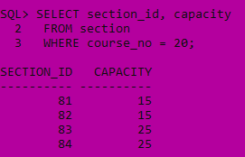

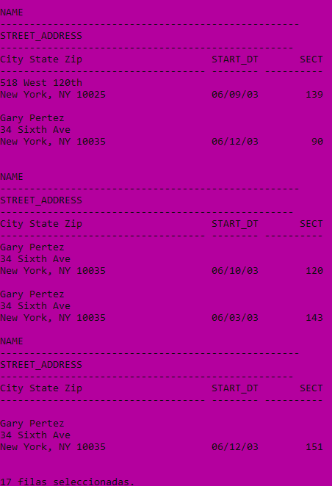

rem [Rischert, 2004,377]

SELECT course_no, SUM(capacity)

FROM section

GROUP BY course_no

HAVING SUM(capacity) <

(SELECT AVG(capacity)

FROM section);

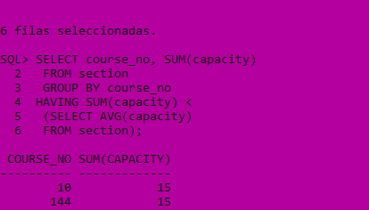

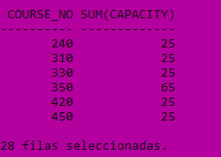

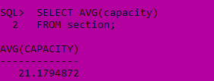

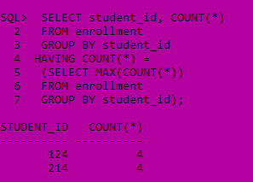

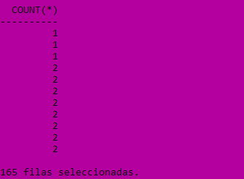

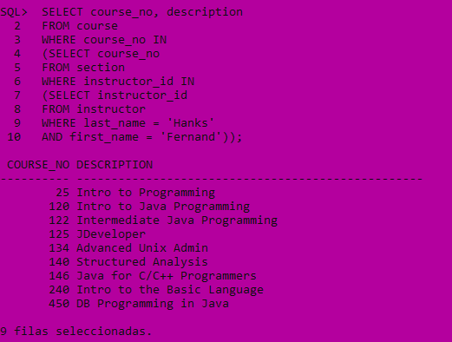

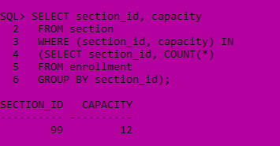

rem [Rischert, 2004,397]

SELECT course_no, section_id

FROM section s

WHERE NOT EXISTS

(SELECT NULL

FROM enrollment

WHERE s.section_id = section_id)

ORDER BY course_no;

## 7.2 exercises

Explain what the following correlated subquery accomplishes.

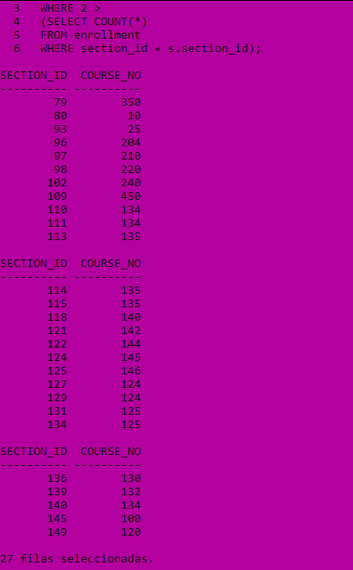

Then write a second query to show the sections without any enrollments (i.e., the SECTION_ID does not exist in the ENROLLMENT table). To determine these sections, you can use the NOT IN operator because the SECTION_ID in the ENROLLMENT table is defined as NOT NULL.

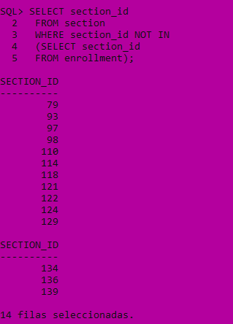

rem [Rischert, 2004,393]

SELECT section_id

FROM section

WHERE section_id NOT IN

(SELECT section_id

FROM enrollment);

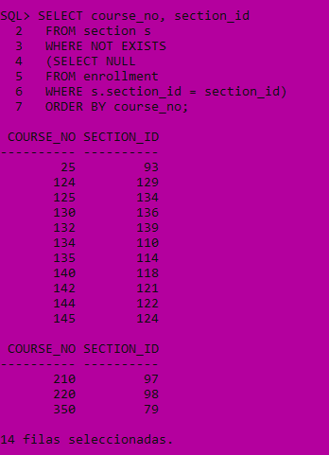

## Lab 7.4 Exercise

rem [Rischert, 2004,417]

SELECT student_id, section_id, numeric_grade

FROM grade g

WHERE grade_type_code = 'FI'

AND numeric_grade > ALL

(SELECT numeric_grade

FROM grade

WHERE grade_type_code = 'HM'

AND g.section_id = section_id

AND g.student_id = student_id);

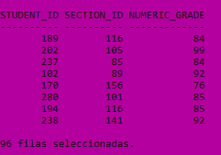

rem [Rischert, 2004,418]

SELECT student_id, section_id, grade_type_code,

MAX(numeric_grade) max, MIN(numeric_grade) min

FROM grade

WHERE student_id = 179

AND section_id = 116

AND grade_type_code IN ('HM', 'FI')

GROUP BY student_id, section_id, grade_type_code;

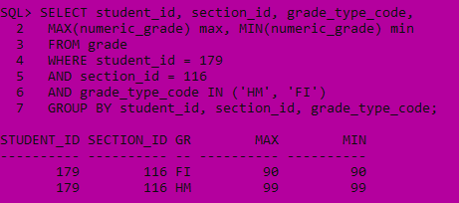

rem [Rischert, 2004,420]

SELECT student_id, section_id, grade_type_code,

numeric_grade

FROM grade

WHERE student_id = 102

AND section_id = 89

AND grade_type_code IN ('HM', 'FI')

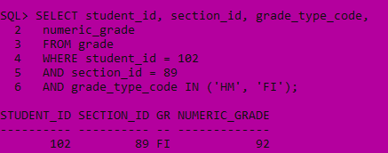

# Chapter 8. Set Operators

rem [Rischert, 2004,425]

SELECT first_name, last_name, phone, COUNT(*)

FROM student

GROUP BY first_name, last_name, phone

HAVING COUNT(*) > 1;

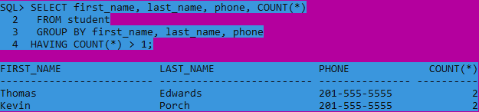

rem [Rischert, 2004,426]

SELECT instructor_id id, first_name, last_name, phone

FROM instructor

UNION

SELECT student_id, first_name, last_name, phone

FROM student

ORDER BY 3;

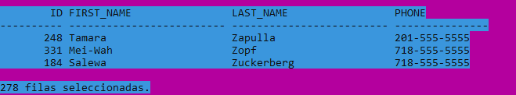

## Lab 8.1 Exercises

rem [Rischert, 2004,427]

SELECT first_name, last_name,

'Instructor' "Type"

FROM instructor

UNION

SELECT first_name, last_name,

'Student'

FROM student;

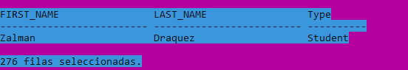

rem [Rischert, 2004,429]

SELECT first_name, last_name,

'Instructor' "Type"

FROM instructor

UNION

SELECT first_name, last_name,

'Student'

FROM student;

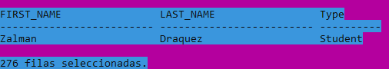

rem [Rischert, 2004,430]

SELECT created_by

FROM enrollment

UNION

SELECT created_by

FROM grade

UNION

SELECT created_by

FROM grade_type

UNION

SELECT created_by

FROM grade_conversion;

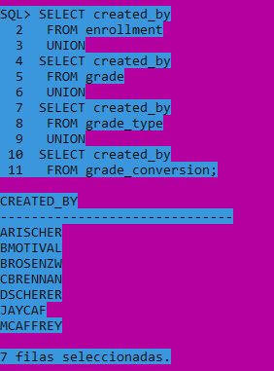

rem [Rischert, 2004,432]

SELECT DISTINCT salutation, CAST(NULL AS NUMBER),

state, z.created_date

FROM instructor i, zipcode z

WHERE i.zip = z.zip

UNION ALL

SELECT salutation, COUNT(*),

state, TO_DATE(NULL)

FROM student s, zipcode z

WHERE s.zip = z.zip

GROUP BY salutation, state;

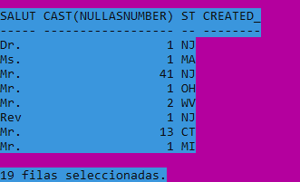

## Lab 8.2 Exercises

rem [Rischert, 2004,440]

SELECT course_no, description

FROM course

MINUS

SELECT s.course_no, c.description

FROM section s, course c

WHERE s.course_no = c.course_no;

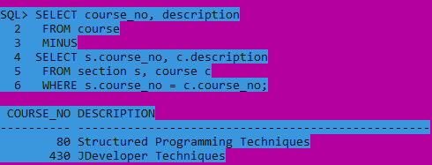

rem [Rischert, 2004,441]

SELECT course_no, description

FROM course c

WHERE NOT EXISTS

(SELECT '*'

FROM section

WHERE c.course_no = course_no);

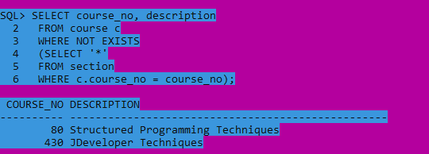

rem [Rischert, 2004,442]

SELECT zip

FROM instructor

INTERSECT

SELECT zip

FROM student;

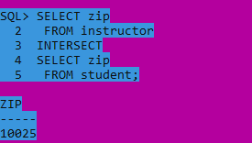

# Chapter 9. Complex Joins

rem [Rischert, 2004,447]

SELECT course_no, description,

section_id

FROM course JOIN section

USING (course_no)

ORDER BY course_no;

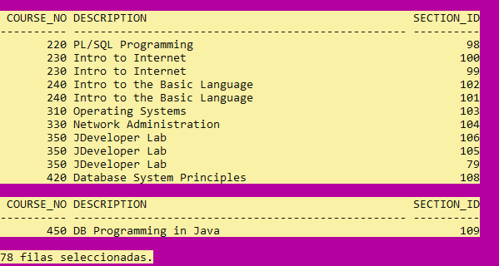

rem [Rischert, 2004,448]

SELECT c.course_no, c.description,

s.section_id, s.course_no

FROM course c LEFT OUTER JOIN section s

ON c.course_no = s.course_no

ORDER BY c.course_no;

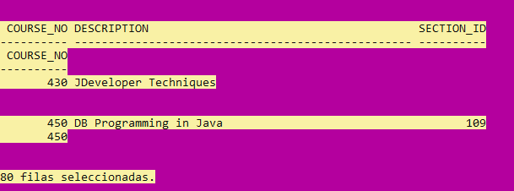

rem [Rischert, 2004,452]

SELECT col1, col2

FROM t1, t2

WHERE t1.col1 = t2.col2(+)

UNION

SELECT col1, col2

FROM t1, t2

WHERE t1.col1(+) = t2.col2;

# Lab 9.1 Exercises

rem [Rischert, 2004,455]

SELECT c.course_no, s.course_no, s.section_id,

c.description, s.start_date_time

FROM course c FULL OUTER JOIN section s

ON c.course_no = s.course_no;

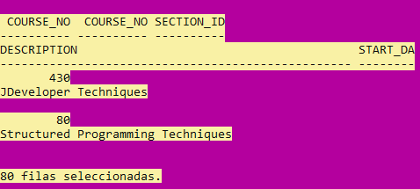

rem [Rischert, 2004,456]

SELECT course_no, description

FROM course

WHERE prerequisite = 350;

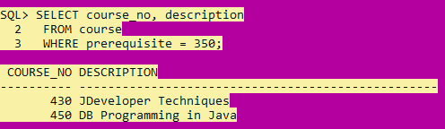

rem [Rischert, 2004,457]

SELECT course_no cno,

description,

prerequisite prereq,

location loc, section_id

FROM course LEFT OUTER JOIN section

USING (course_no)

WHERE prerequisite = 350;

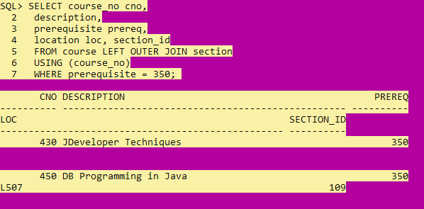

rem [Rischert, 2004,460]

SELECT c.course_no cno, s.course_no sno,

c.description,

c.prerequisite prereq,

s.location loc, s.section_id

FROM (SELECT *

FROM course

WHERE prerequisite = 350) c LEFT OUTER JOIN

(SELECT * FROM section

WHERE location = 'L507') s

ON (c.course_no = s.course_no);

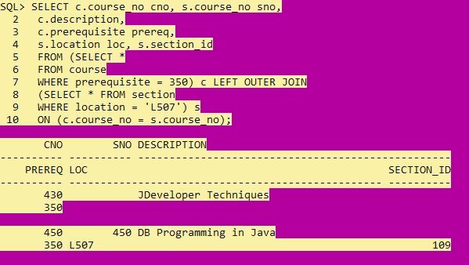

rem [Rischert, 2004,461]

SELECT c.course_no, c.description

FROM course c, section s

WHERE c.course_no = s.course_no(+)

AND s.course_no IS NULL;

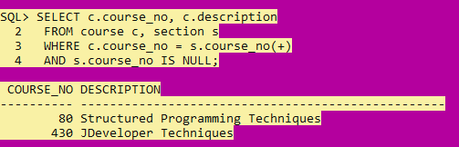

rem [Rischert, 2004,462]

SELECT city, state, zip,

(SELECT COUNT(*)

FROM student s

WHERE s.zip = z.zip) AS student_count

FROM zipcode z

WHERE state = 'CT';

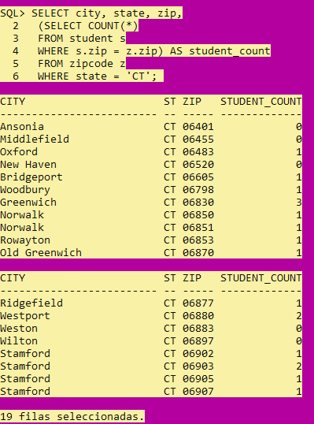

rem [Rischert, 2004,471]

SELECT student_id, section_id, numeric_grade

FROM grade g

WHERE grade_type_code = 'FI'

AND section_id = 86

AND numeric_grade < ANY

(SELECT numeric_grade

FROM grade

WHERE grade_type_code = 'MT'

AND g.section_id = section_id

AND g.student_id = student_id);

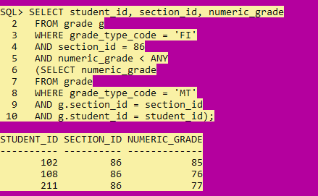

rem [Rischert, 2004,472]

SELECT DISTINCT a.student_id, a.last_name,

a.street_address

FROM student a, student b

WHERE a.street_address = b.street_address

AND a.zip = b.zip

AND a.student_id <> b.student_id

ORDER BY a.street_address;

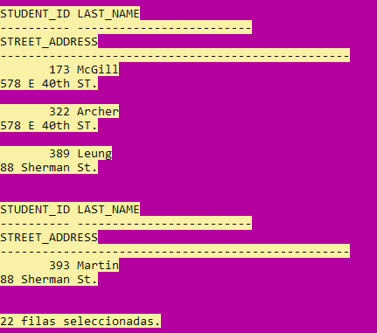

rem [Rischert, 2004,474]

SELECT c1.course_no,

SUBSTR(c1.description, 1,15) course_descr,

C1.prerequisite,

SUBSTR(c2.description,1,15) pre_req_descr

FROM course c1, course c2

WHERE c1.prerequisite = c2.course_no(+)

ORDER BY 1;

